Name : T.Vishnu vikas rao

Reg no : 192125036

Course Code : CSA0726

**COMPUTER NETWORKS LAB EXPERMIENTS**

**DAY-2**

1. Functionalities of TCP, UDP

**AIM :** to create Functionalities of TCP, UDP in packet tracer

step1:-first take 1 server

step2:-link that server to 1 server , 4 pc and 1 switch

step3:-connect that hubs and switches with server and pc with connection

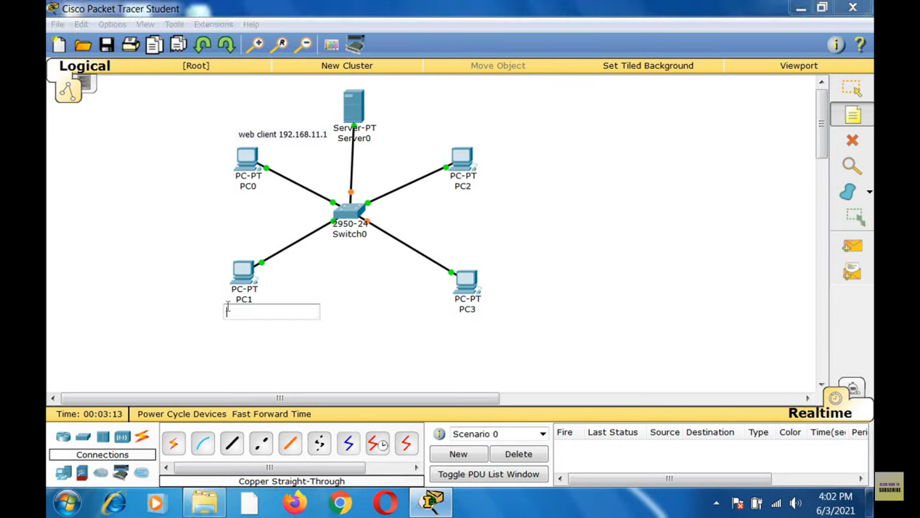

step4:-after connection Functionalities of TCP, UDP in packet tracer

step5:-if message send correctly you got successfull other wise recheck the connections

Step6:- then the Functionalities of TCP, UDP in packet tracer Packet Tracer Distance

is successfully simulated.

